**CPP ASSIGNMENT 2**

Submitted By –

Mithlendu Kumar

[Krakesh9771@gmail.com](mailto:Krakesh9771@gmail.com)

Q1 Write a program to calculate the sum of first 10 natural number.

Code And Output

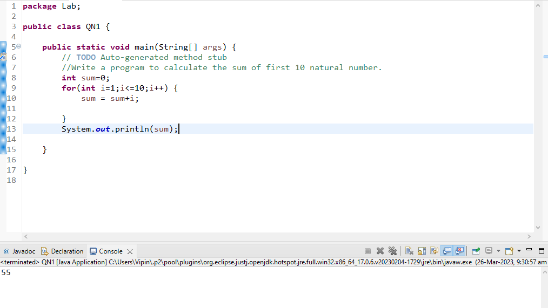

Q 2 Write a program that prompts the user to input a positive integer. It should then print the multiplication table of that number

Code And Output

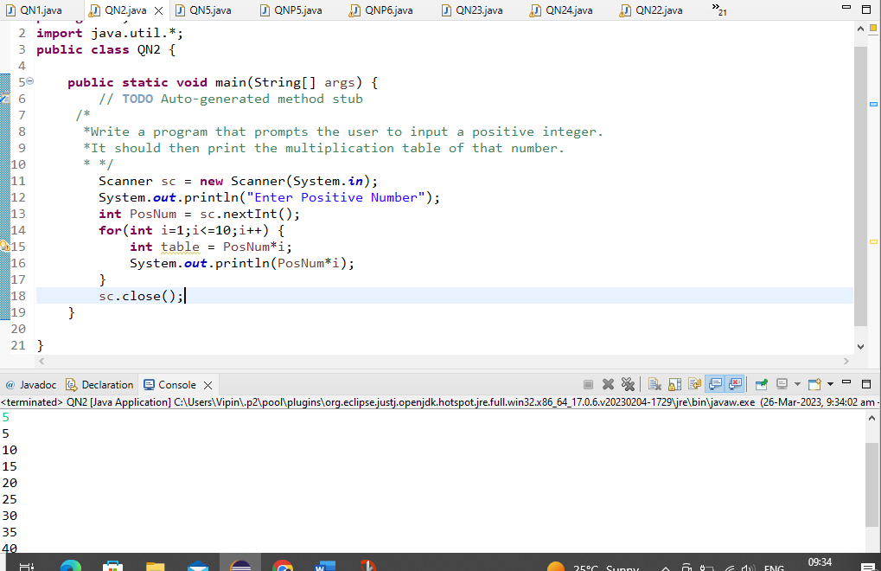

Q 3 Write a program that prompts the user to input an integer and then outputs the number with the digits reversed. For example, if the input is 12345, the output should be 54321.

Code And Output

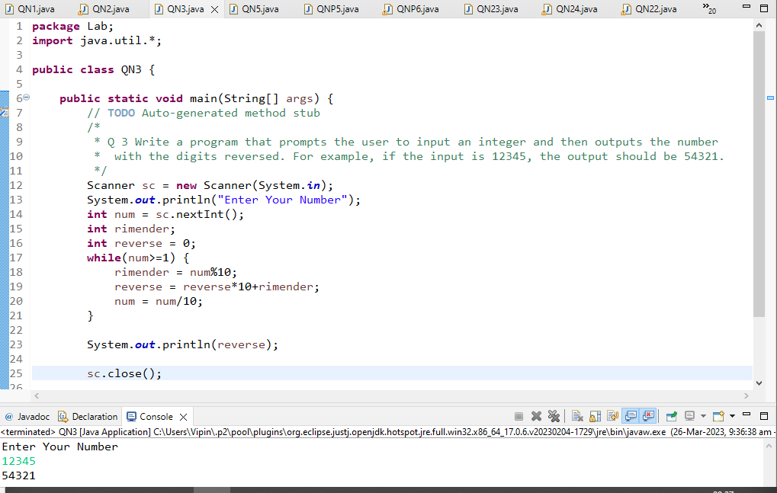

Q 5 Write a program to print out all Armstrong numbers between 1 and 500. If sum of cubes of each digit of the number is equal to the number itself, then the number is called an Armstrong number.  
For example, 153 = ( 1 * 1 * 1 ) + ( 5 * 5 * 5 ) + ( 3 * 3 * 3 )

Code And Output

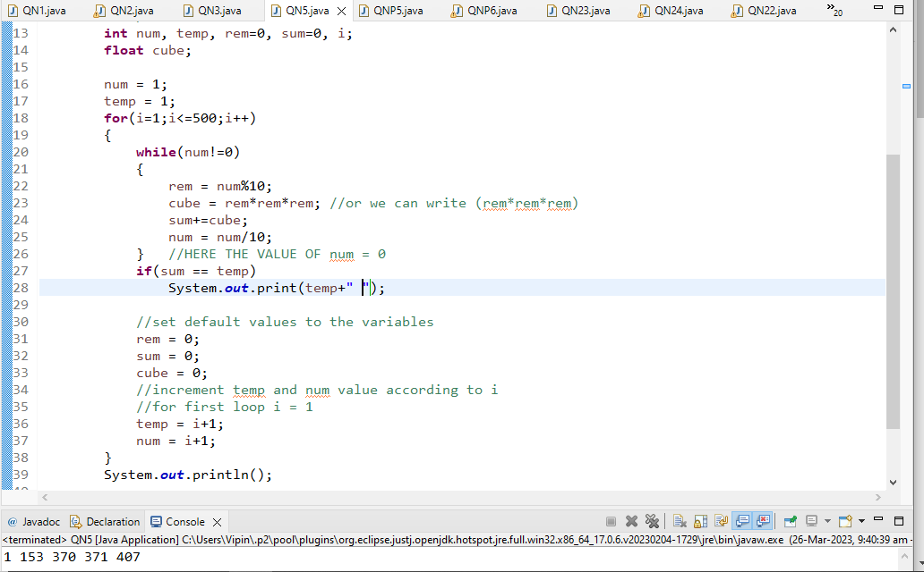

Q 6 Write a program to print Fibonacci series of n terms where n is input by user :  
0 1 1 2 3 5 8 13 24 .....

Code And Output

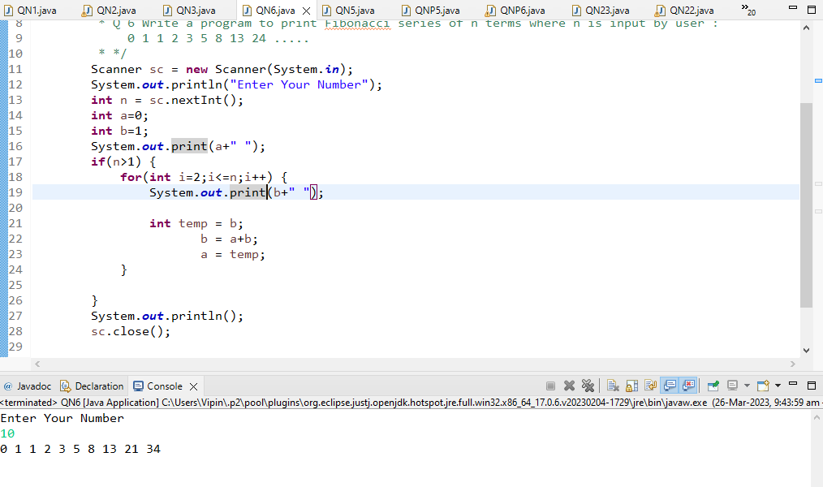

Q 7 Write a program to print following :

(i)  
  
**********  
**********  
**********  
**********

Code And Output

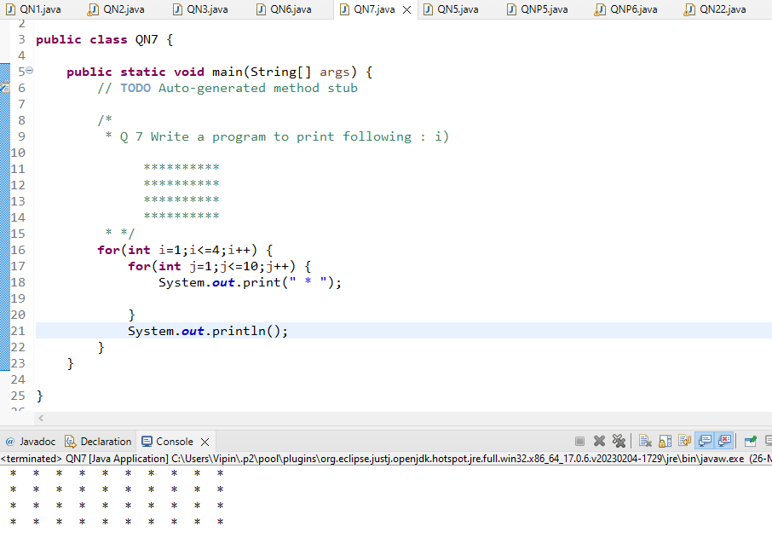

ii)  
  
*  
**  
***  
****  
*****

Code And Output

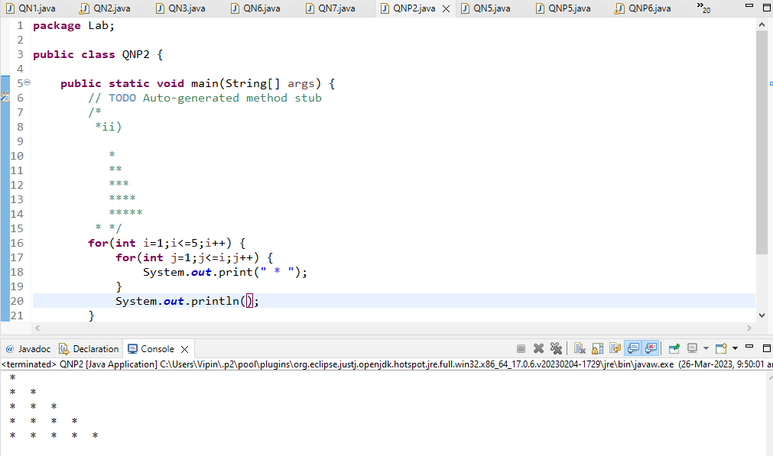

iii)  
  
         *  
      *   *  
     * *     *  
  *    *    *     *

Code And Output

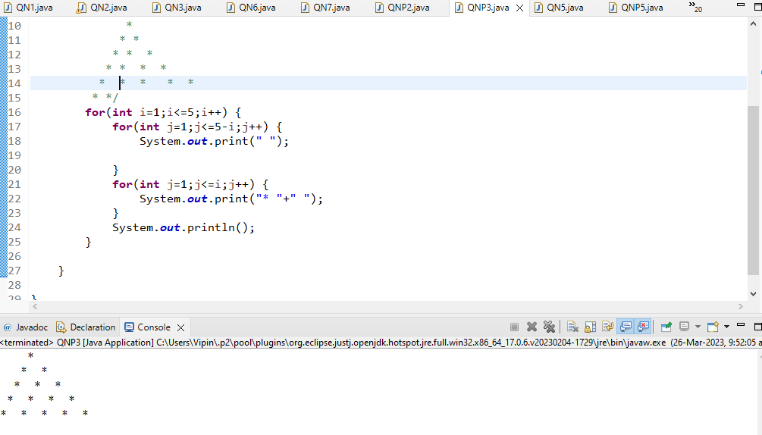

iv)  
  
        *  
      ***  
    *****  
  *******  
*********

Code And Output

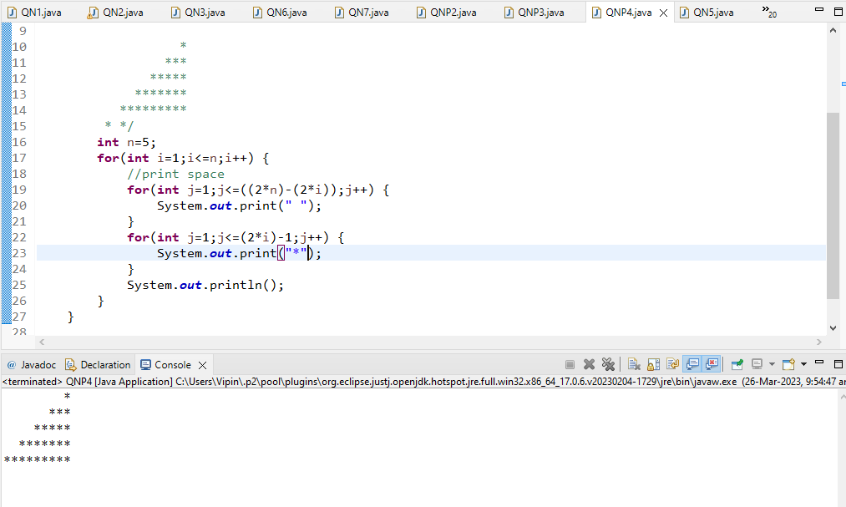

v)  
  
        1  
      222  
    33333  
  4444444  
555555555

Code And Output

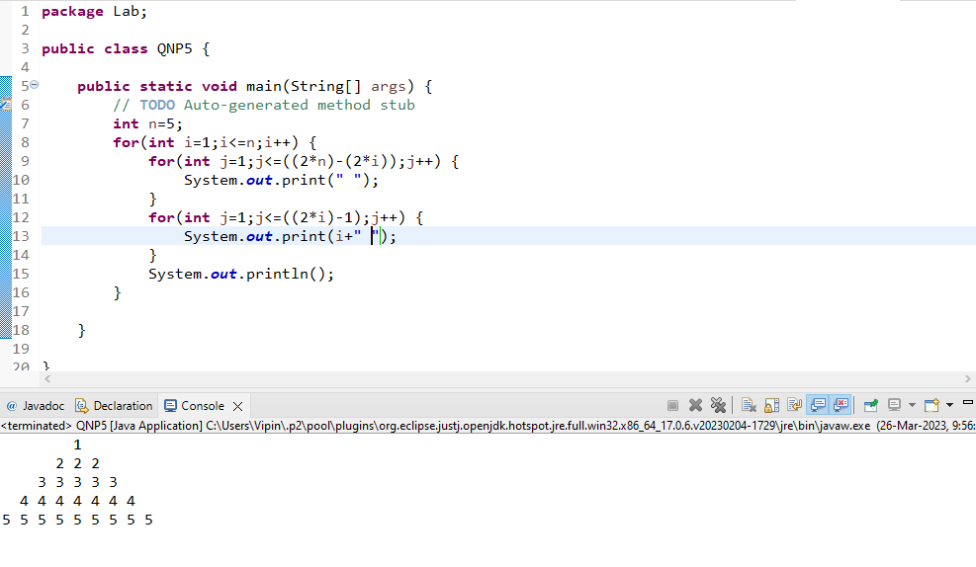

vi )     ABCDEEDCBA  
         ABCD  DCBA  
         ABC      CBA  
         AB         BA  
         A             A

Code And Output

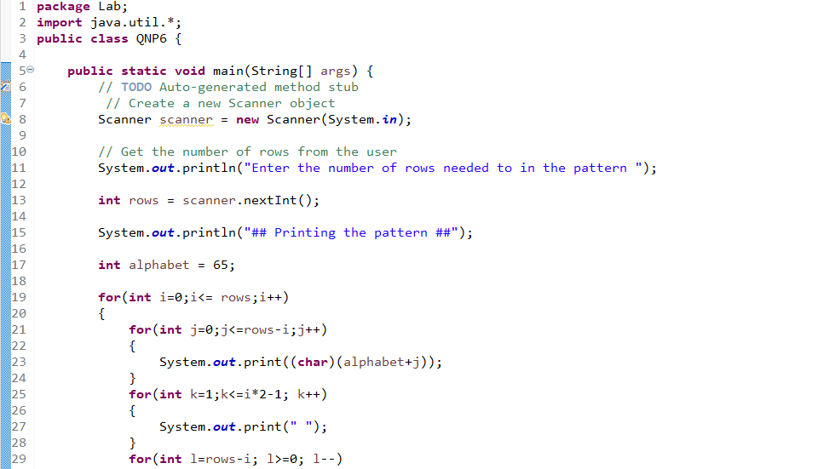

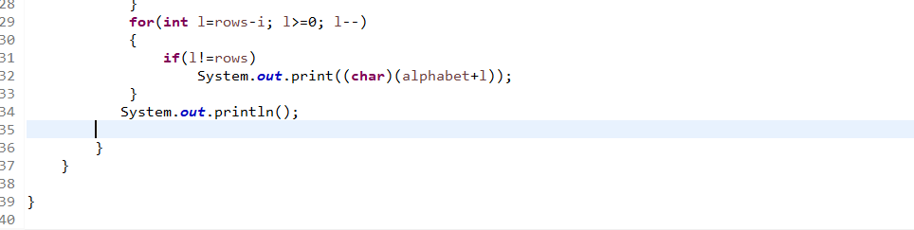

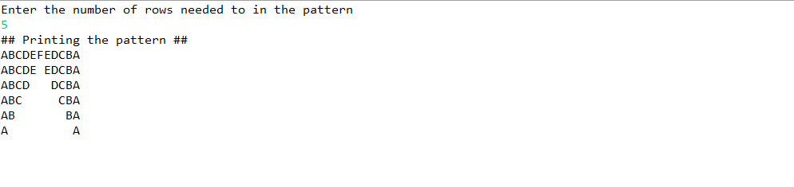

Q9 Write a program to check if given number is prime or not

Code And Output

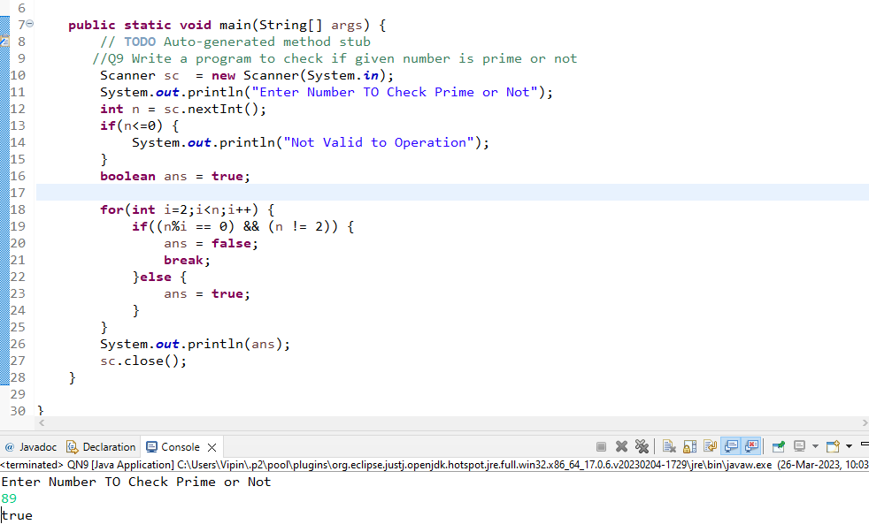

Q 8 Write a program in java to find the sum of the even and odd digits of the number which is given as input

Code And Output

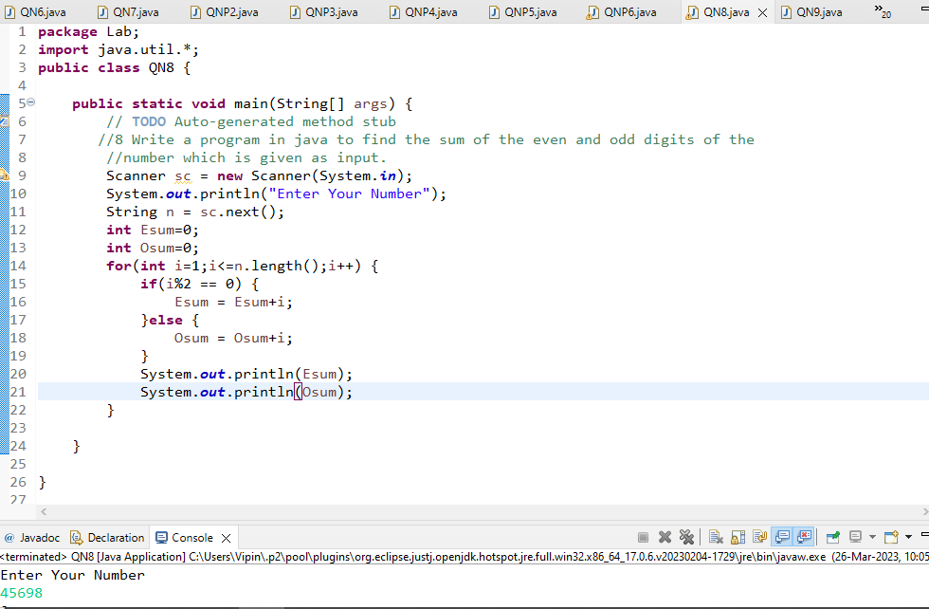

Q 10 write a program to print prime numbers between 2 to 20.

Code And Output

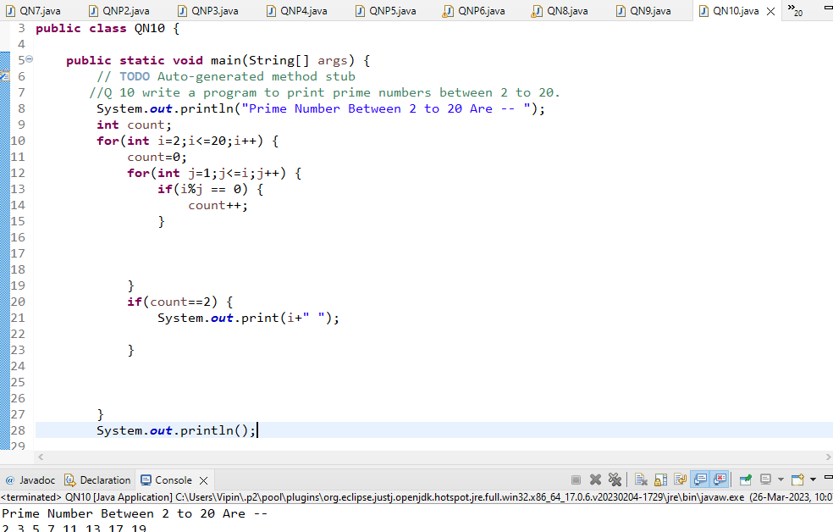

Q 11 Write program to find largest among three numbers

Code And Output

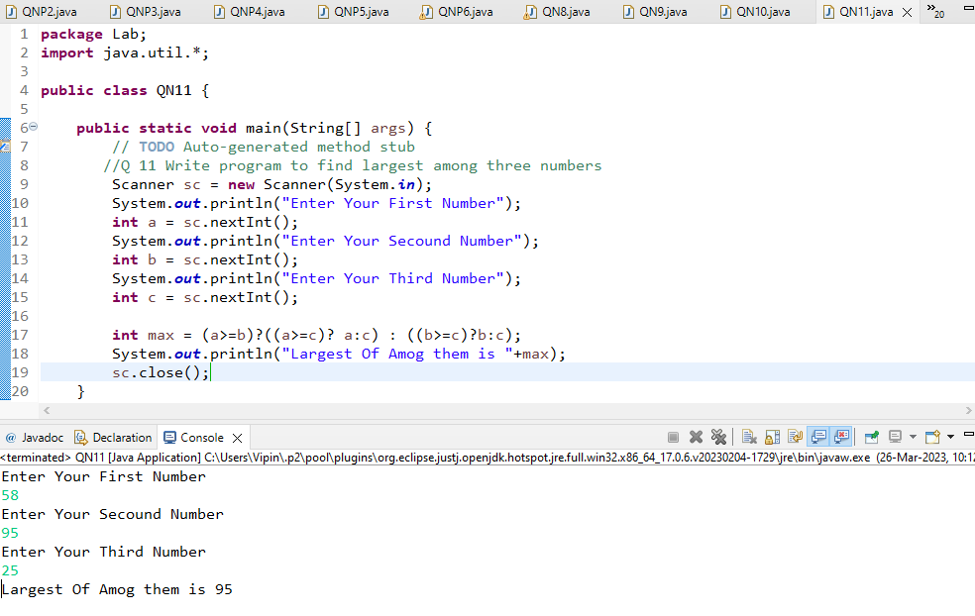

Q 20 Write a program to find sum of all integers greater than 100 and less than 200 that are divisible by 7

Code And Output

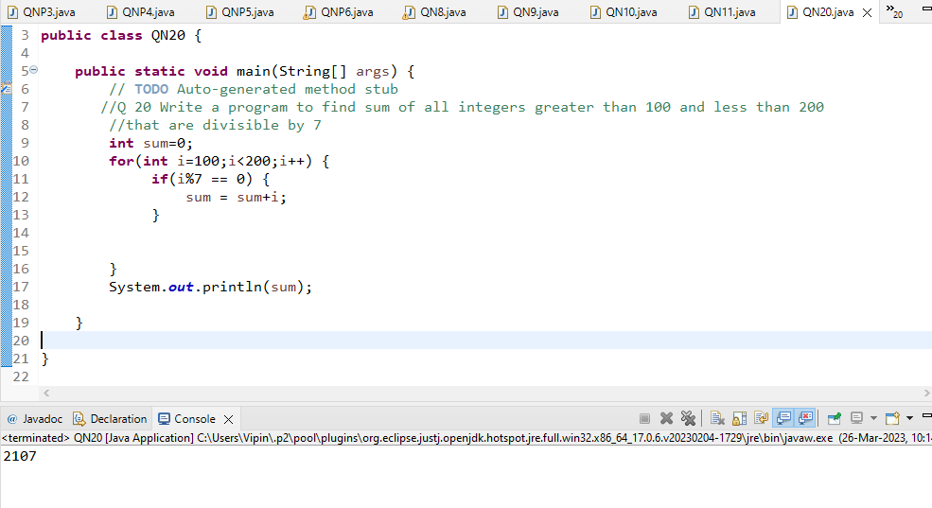

Q 21 8.    Write a Java program to print numbers between 1 to 100 which are divisible by 3, 5 and by both.

Code And Output

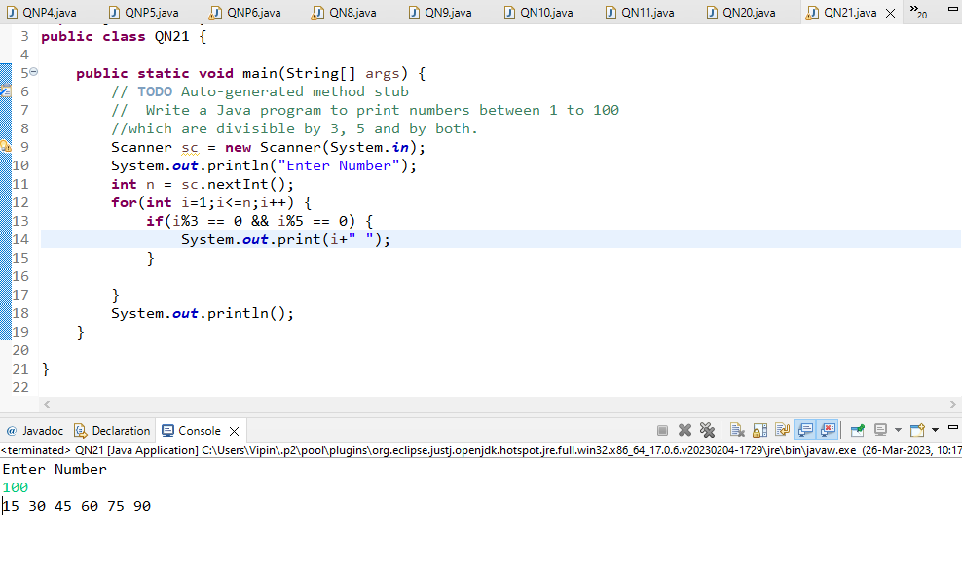

Q 22 create a menu driven application in java that show  
   "Add"        Add two number  
  "subtract"  Subtract two number  
  "Multiple"    Multiple two numbers  
  "Exit "           Exit  
  
Ask two numbers from user  and as per user choice perform necessary action using switch command

Code And Output

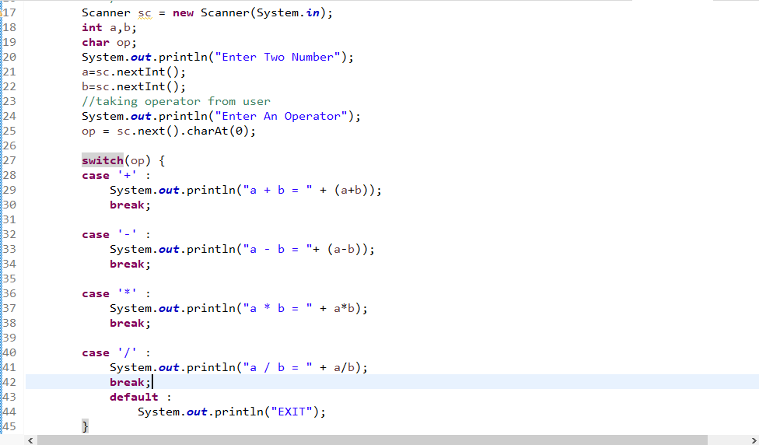

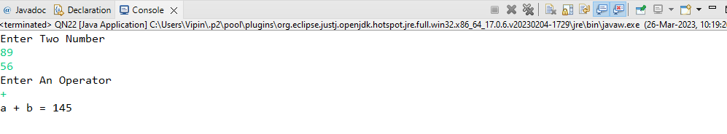

Q 23 Write a program to display first 1 to 20 even number on screen. Terminate the program when number 16 is found using break Command.

Code And Output

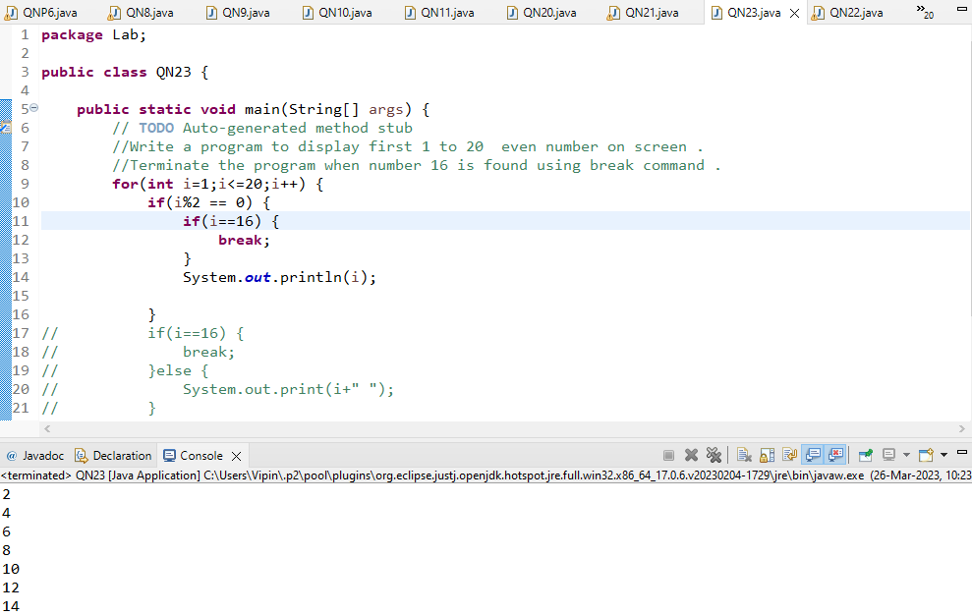

Q 24 Write a Java program that accepts two double variables and test if both strictly between 0 and 1 and false otherwise.  
Hint n1 > 0 && n1 < 1 && n2 > 0 && n2 < 1

Code And Output

